Anik Shaikh

Enrolment number – 23162121021

Batch 31

Class 3A

Q.1) Write an SQL query to display maximum salary from employee table.

Q.2) Write an SQL query to display employee name who is taking maximum salary.

Q.3) Write an SQL query to display second highest salary from employee table?

Q.4) Write an SQL query to display employee name who is taking second highest

salary.

Q.5) Write an SQL query to display all the dept names along with no of employees

working in it.

Q.6) Write an sql query to display all the employee names where no. of employees are

less than 2.

Q.7) Display the name of employee who works in department having count of employee

less than 2.

Q.8) Write a query display highest salary department wise and name of employee who

is taking that salary.

Q.9) Find the name of employees who are working on a project?

Q.10) Find the details of employee who is working on at least one project?

Code:

create database Prac_7;

use Prac_7;

create table employee (eid int primary key, ename varchar(50), address varchar(100), dept varchar(50), salary int);

insert into employee values (1, 'ram', 'chd', 'hr', 10000), (2, 'amit', 'delhi', 'mrkt', 20000), (3, 'ravi', 'pune', 'hr', 30000), (4, 'nitin', 'bang', 'mrkt', 40000), (5, 'varun', 'chd', 'it', 50000);

create table project (eid int, pid varchar(10), pname varchar(50), location varchar(50), foreign key (eid) references employee(eid));

insert into project values (1, 'p1', 'iot', 'bang'), (5, 'p2', 'big data', 'delhi'), (3, 'p3', 'retail', 'mumbai'), (4, 'p4', 'android', 'hyderabad');

select max(salary) as max_salary from employee;

select ename from employee where salary = (select max(salary) from employee);

select max(salary) as second_highest_salary from employee where salary < (select max(salary) from employee);

select ename from employee where salary = (select max(salary) from employee where salary < (select max(salary) from employee));

select dept, count(*) as employee_count from employee group by dept;

select ename from employee where dept in (select dept from employee group by dept having count(*) < 2);

select ename from employee where dept in (select dept from employee group by dept having count(*) < 2);

select e.dept, e.ename, e.salary from employee e inner join (select dept, max(salary) as max_salary from employee group by dept) m on e.dept = m.dept and e.salary = m.max_salary;

select distinct e.ename from employee e inner join project p on e.eid = p.eid;

select e.* from employee e where exists (select 1 from project p where p.eid = e.eid);

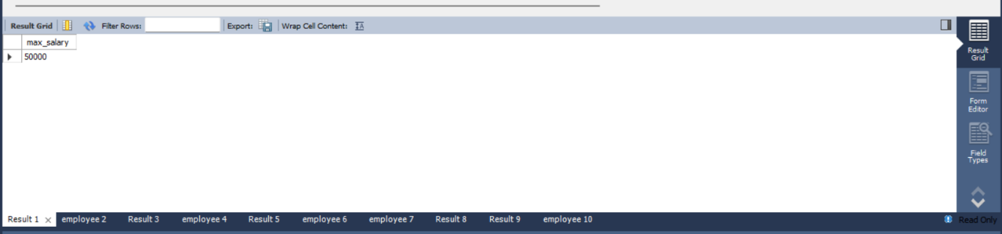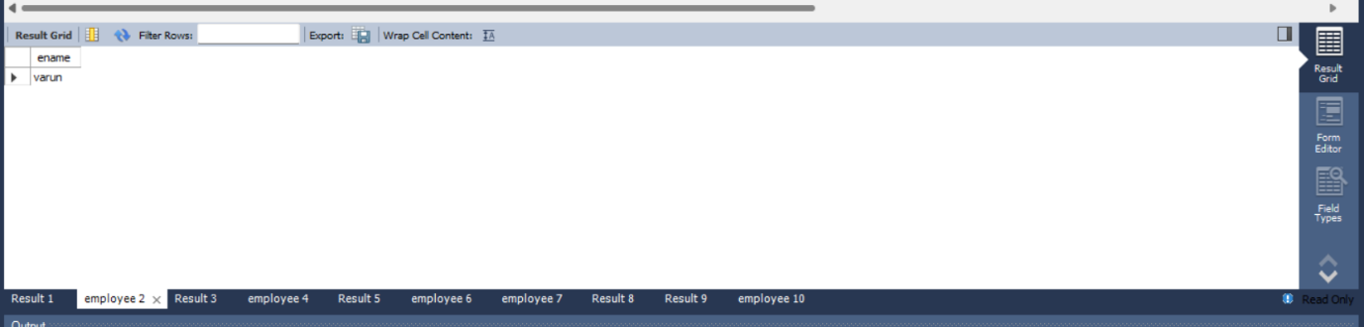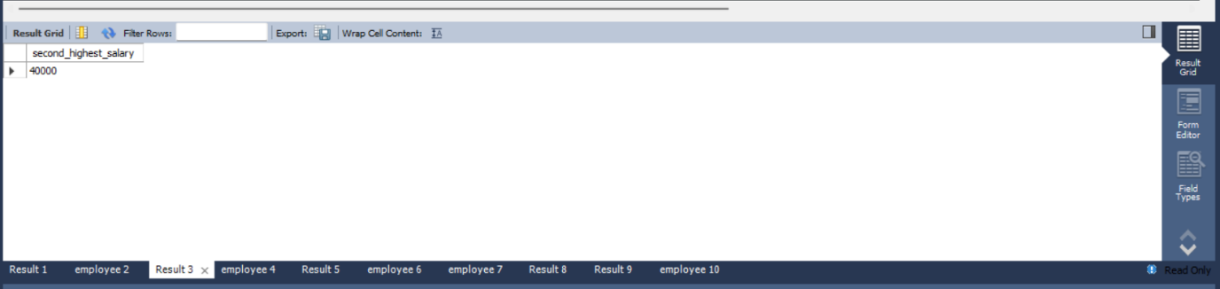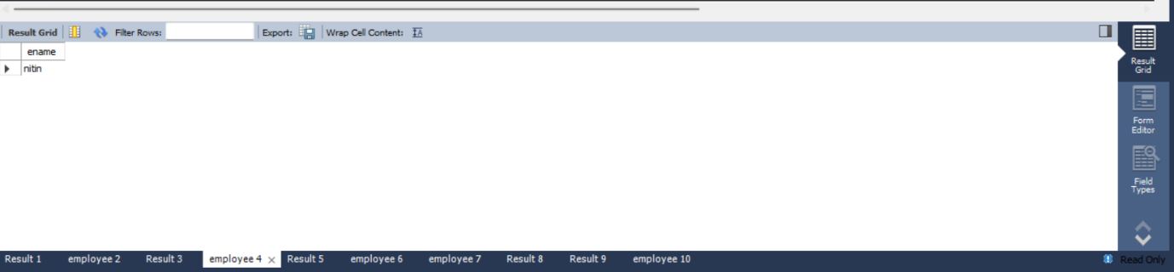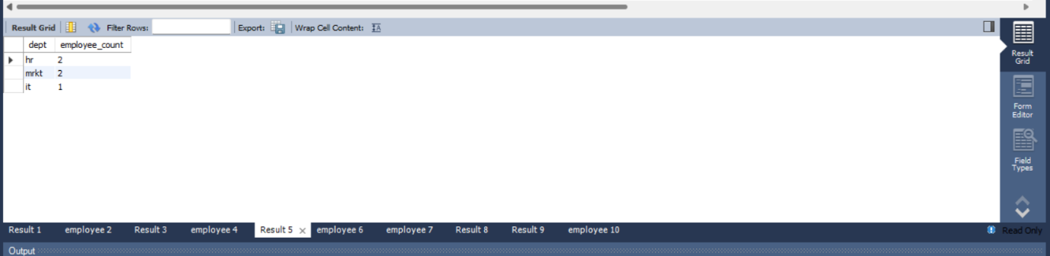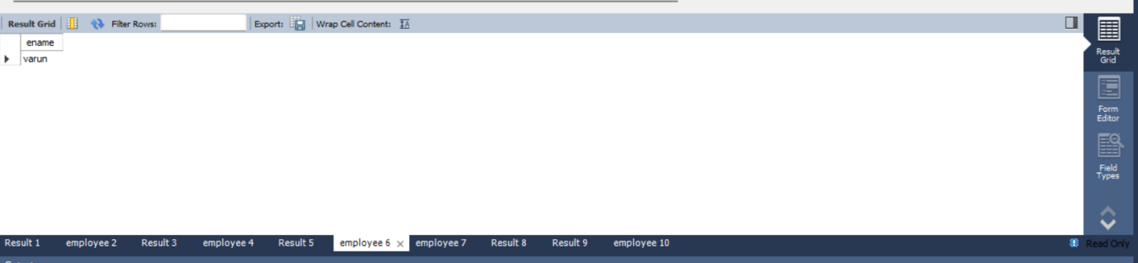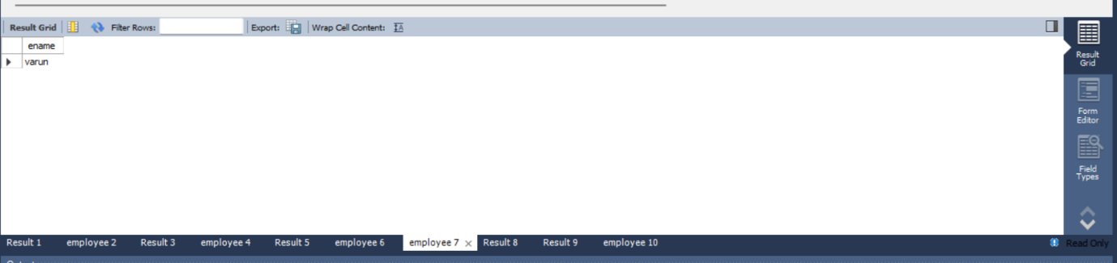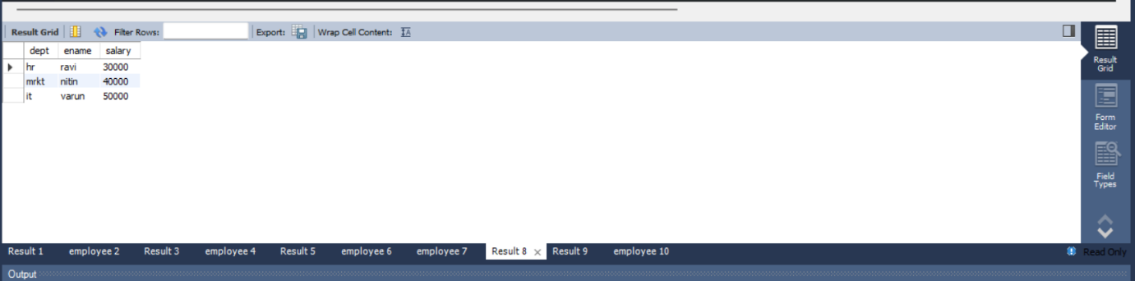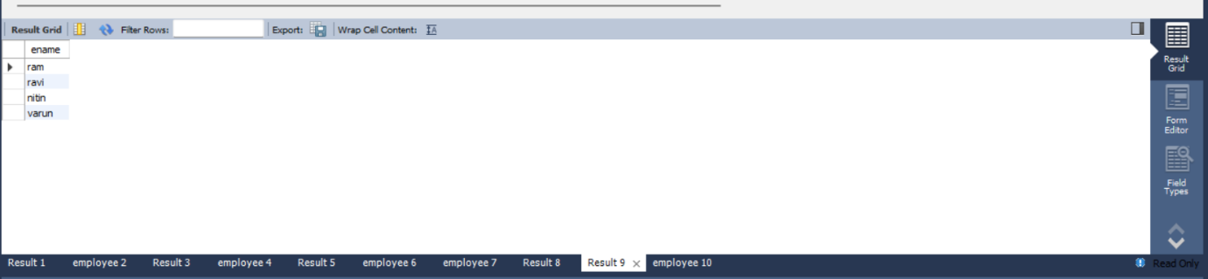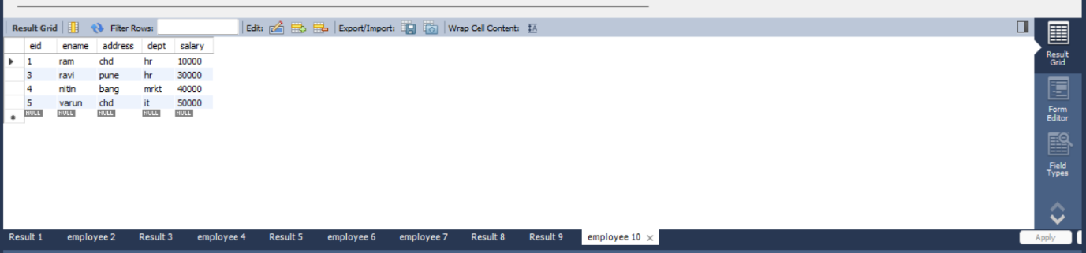

Action log:

